"In the Liveliest Place, my Mother's Bosom, there was Death" - Mother-Daughter Relationships in the Work of Rachel Nemesh, Second-Generation Holocaust Survivor

Shahar Marnin-Distelfeld

Abstract
This article focuses on the artwork of Israeli artist, Rachel Nemesh, a Second-Generation Holocaust Survivor born in 1951.The assemblage of drawings and paintings to be discussed is being exhibited in her solo exhibition, One Flesh (curator: Michal Shachnai Yaacobi), held at the Israeli Art Gallery in the Memorial Center, Kiryat Tivon. The corpus analysis will be divided into four themes: a. The Big Mother – works describing the elderly mother of Nemesh in a monumental manner; b. Pieta versions - works focusing on bodily scenes of mother and daughter closely tangled; c. Body-Parts: works showing randomly detached body organs; d. Domestic Space - the artist's mother in her home. The study will be framed by two main fields: art centering on the Holocaust and feminist ideas focusing on mother-daughter relationships. Theoretical and visual examination will be enhanced by interviews with the artist aiming at profoundly decoding her artwork, claimed to resonate a feminine artistic language. An attempt to formulate an original interpretation of Holocaust Second-Generation's art, combined with a feminist point of view, will be made here. Rachel Nemesh's artwork is being investigated here for the very first time.

Key words: Holocaust art, Second-Generation art, feminist art, mother-daughter relationship

Introduction
In art relating to the Holocaust in Israel, images of motherhood are prevalent. As a Second-Generation Holocaust Survivor born in Israel in 1951, much of Rachel Nemesh’s artwork deals in observations of her mother and their mother-daughter relationship. In her solo art exhibition, One Flesh (curator: Michal Shachnai Yaacobi), held at the Israeli Art Gallery in the Memorial Center, Kiryat Tivon in March-August 2020, this artist displayed oil paintings that, through profound realism, describe symbolic scenes of her mother, the mother in her domestic space, the mother and daughter relationship and a few body parts images. The assemblage of pieces comprises two main fields that will be analyzed and discussed in this article: art that deals in the Holocaust – especially art created by Second-Generation Holocaust Survivors – and feminist thought focusing on mother-daughter relationships. While the former relates to western and Israeli art history and the latter to psychological and sociological theories, their combination enables an in-depth discussion of the artwork of Nemesh, enhanced by interviews held with the artist.
This article includes four sections and aims at enriching the field of Israeli contemporary art, analyzing Nemesh’s art. First, this paper discusses the term 'Second Generation' with regard to the history of Israeli art, reviewing trends that are typical of the artwork of Second-Generation Holocaust Survivors over the years. The second part of this paper dwells on the issues of mothers and mother-daughter relationships in artwork pertaining to the Holocaust in Israel. Next, this paper discusses central feminist theories addressing the unique and complex mother-daughter relationship, and finally presenting an analysis of the artwork of Rachel Nemesh.

'Second-Generation' in Plastic Arts
The term 'Second-Generation' emerged in the 1980s in relation to children of Holocaust survivors, born after World War II (WWII) and raised among Holocaust survivor families. This term is related to the collective consciousness of the generation’s sons and daughters, possessing shared components in their identity formation in relation to their life experiences in light of parents who survived the horrors of the war and who suffered the terrible loss of family members.
Second-Generation Holocaust Survivors are a heterogeneous generational segment, with a range of religious, financial, and political backgrounds. Some experienced their parents’ trauma to a great extent, while others – much less so. Their parents’ life circumstances and personalities dictated their life patterns after the war. Some shared their experiences with their family in detail while others maintained silence. Yet in most cases, some degree of their experiences did permeate into family life – both conscientiously and unconscientiously.
Research about Second-Generation Survivors first saw light at the end of the 1970s, dealing in the perspectives of the next generation, rather than those of the parents who had actually survived the Holocaust. In her book Memorial Candles (1990), Dina Wardi presents a therapeutic-psychological aspect and addresses the shared characteristics of Holocaust Survivors and their families. Wardi also portrays the national-cultural connection of the Israeli society’s attitude towards the Holocaust over the years as a significant factor in the development of the Second-Generation’s identity. In addition to research developments on the psychological aspects of this population in the 1970s, cultural research also emerged, examining how Second-Generation characteristics are expressed – especially through Hebrew literature and poetry, yet also through plastic arts.
Widening the perspective of Holocaust expression, stemming from the metanarrative focused on sanctioning the victims, to comprise other potential layers of references, enabled new approaches of artistic interpretations of the Holocaust as a personal experience. A number of exhibitions featured the Holocaust from a personal perspective in the late 1970s included Haim Maor’s exhibitions at the Kibbutz Gallery in Tel Aviv in 1978 and 1979, Rivka Miriam’s exhibition at the Kerem Institute in Jerusalem in 1979, and Yocheved Weinfeld’s exhibition at the Israel Museum in Jerusalem in 1979. Miriam exhibited pictures of images resembling ghosts to represent family members who had been killed. Weinfeld also displayed images that were bluntly and directly related to the Holocaust. While these two artists addressed the Holocaust in a straightforward figurative manner – an approach also characteristic of Nemesh’s artwork – their works were not recognized by the establishment and as such, did not become etched in the historiography of Holocaust Israeli art.
Moshe Gershuni’s artwork has been described as groundbreaking with regards to Israeli art and the Holocaust, as he managed to address it from a contemporary point-of-view, without transforming it into a superficial or ideological manipulation. While Gershoni is not a Second-Generation survivor, he is albeit recognized as an artist whose work touches upon the Holocaust, thus becoming a milestone in the acceptance of art addressing the Holocaust. However, it was Miriam and Weinfeld who in 1979 laid the foundation for Second-Generation artwork that deals in the Holocaust. Either way, the start of the 1980s saw the emergence of intensive engaging in Second-Generation artwork, and exhibitions relating to the Holocaust began to be displayed in both central and peripheral museums.
Such exhibitions, which included historical, conceptual, and stereotypical images relating to Holocaust memories, included work by Haim Maor and Evyatar Stern. At the beginning of the 1990s, the subject of the Holocaust became present in Israeli art and such artwork could have often been seen in more general group exhibitions. At the same time, Second-Generation artists continued with their solo exhibitions in both small galleries and central museums. In 1997, The Museum of Israeli Art, Ramat Gan, hosted three solo exhibitions that directly dealt in the Holocaust: Itamar Newman, 193945: A Tribute to Primo Levi; Jacob Gildor, The Private Hell; and Natan Nuchi, Digital Sketches. These three artists presented vivid images of burning, destruction, and lifeless images.
In his 1997-1998 exhibition, Live and Die as Eva Braun, held at the Israel Museum in Jerusalem, artist Roee Rosen designed a virtual reality regarding Hitler’s mistress. The exhibition raised questions about the manner in which memories and images from the Holocaust should be imprinted into our personal and collective memory. Rosen is considered a groundbreaking artist as he dared to build the exhibition around the aggressor, rather than the victim – provoking heavy criticism and lengthy discourse on the legitimacy of art as a means for addressing such topics. However, when the exhibition was held again almost twenty years later (in 2016 at the Tel Aviv Museum), it was received with indifference, following the cultural processes that the Israeli society had undergone over the years which enabled the expanding of the discourse on the Holocaust to areas that had previously been considered taboo.
In 1998, three articles were published on art and the Holocaust. Haim Maor wrote about the dialectics between the difficulty in dealing with the Holocaust through art and the attempts – mainly by Second-Generation artists – to find creative means of expression. Sarit Shapira claimed that because of its taboo in Israeli society, the Holocaust penetrated Israeli art in an indirect, metaphorical, and concealed manner. Dalia Manor wrote about art and the Holocaust in response to the absence of Israeli artists from the international exhibition, After Auschwitz: Reactions to the Holocaust in Contemporary Art. Manor addressed the alienation of the Holocaust in Israeli historiography as it focuses on collective questions rather than on the personal identities of Second-Generation artists. However, unlike the claims of these three writers, in 1999, the Holocaust and related concepts were placed at the forefront of the visual stage of Israeli art when Simcha Shirman and Philip Ranzer – two Second-Generation artists – exhibited their work at the Israeli pavilion at a Biennale in Venezuela. While Shirman dealt in issues of victims versus aggression, Ranzer dealt in questions relating to refugees and immigration.
Over the past twenty years, the topic of the Holocaust has continued to present itself in Israeli art, challenging '…the very notion of one over-riding truth or 'story''. It seems that art contributes to making Holocaust commemoration a dynamic arena 'committed to exploring new modes of referentiality' suggesting a rounded picture of the Holocaust. In 2002, an exhibition – Lying Within the Skin: Images of Silence and Absence in the Art of Second Generation Holocaust Survivors – was held at the Memorial Center in Kiryat Tivon. This exhibition sought to present Second-Generation artists and art as a distinct phenomenon examining the characteristics of their work. What especially stood out in this exhibition were the visual strategies that indirectly dealt with issues relating to the Holocaust through metaphors and de-familiarization, without directly addressing the Holocaust itself . In contrast, artist Rachel Nemesh exhibited her artwork at the same gallery – almost twenty years later – with direct and distinct reference to the Holocaust.
At the beginning of the century, a number of solo exhibitions were dedicated to the Holocaust. In 2008, two group exhibitions of Second-Generation artists were held parallel in Israel and Hungary: Layers of Memory at the House of Artists in Tel Aviv and In the Holocaust's Shadow – Israeli Second-Generation Artists in Maneh Gallery, Budapest. Both exhibitions presented a range of methods for dealing with the issue of the Holocaust, including photographs, objects, and the identification tattoo on the arms of Auschwitz-Birkenau survivors. In 2011, Haim Maor presented a comprehensive exhibition at the Open Museum Tefen called They are Me, where a collection of his artwork exploring his identity in relation to the Holocaust was displayed.
Just as Moshe Gershuni and his artwork from the 1980s became a milestone in Israeli art addressing the Holocaust, artists who are not Second-Generation also have employed aspects of the Holocaust, even borrowing them to investigate other more current or universal topics – often leading to heated arguments within and outside the art world. Liat Steir Livny defines this expansion of addressing the Holocaust in relation to other topics – especially the Arab-Palestinian conflict – as politicization of the Holocaust, and reviews this trend from the 1940s to the current day. Furthermore, the sensational exhibition Mirroring Evil: Nazi Imagery/Recent Art that was held at the Jewish Museum in New York in March 2002, inspired the provocative artistic addressing of the Holocaust in Israel. At the exhibition, visitors were confronted with the Nazis and their propaganda and power mechanisms – an approach that was typical of David Wakstein in his Explosion exhibition and of Boaz Arad in his VoozVooz exhibition – all three being held at about the same time.
A few years later, over the past decade, the phenomenon of Israeli artists provocatively touching on the Holocaust has become routine. While in the past the inability to deal with the monster led to a 'repressed' memory model – expressed through the increasing use of abstract rather that figurative art – newer models can now be seen, reflecting the memory of the Holocaust among young artists – some even Third-Generation survivors. These artists address the Holocaust in an ironic, extraverted, and blunt manner. The distance of these young artists from the intimate Holocaust experience enables them to observe it in a direct, doubtful, and monstrous manner – one that would not have been previously possible. And yet, Second-Generation artists who are now in their 70s or 80s, also continue to create art addressing the Holocaust, being influenced by the contemporary and changing discourse.

Mothers and Mother-Daughter Relationships in Holocaust Art
The review presented above does not address gender-related perspective as a separate framework for observing and analyzing Holocaust-related artwork, although such aspects have been occasionally discussed as part of other topics. The topic of gender has also received minimal attention at Second-Generation exhibitions, both in catalogs and in relevant articles. Exceptions can be seen in Mor Presiado’s research on female images in general and on mother figures in Holocaust art, in particular. The first exhibition that addressed gender aspects as a prism for analyzing art was Motherhood in the Shadow of the Holocaust, exhibited at the Bar-Ilan University Leiber Center Gallery for Exhibitions in 2014. Presiado, co-curator of the exhibition together with Lea Fish, sought to present the artwork of First and Second-Generation (and even Third-Generation) women in light of gender concepts relating to the mother and female roles within the family and community.
In line with the feminist approach, each female artist who exhibited, had her own individual feminine experience when creating art, resulting in multifaceted and varied outcomes. As such, not only do the artworks of First, Second and Third-Generation survivors present a range of topics and perspectives, but they also capture the zeitgeist through various media and techniques. Depicting images of mothers at home and in the Ghetto during the war, these female artists portray women figures as a main source of power and support for the family; as mothers who are helpless victims; as complex motherhood figures.
However, mother figures in Israeli art were mainly related to models that were accepted in Western culture and that presented mothers as general and representative images. Few female artists depicted their own private mothers. Mothers were presented as Mother Earth, as a pure Madonna based on Mother of Christ, as a queen, mother of the future heir, or as a bourgeois mother within the home. In penetrating the visual field, Zionism led to the emergence of the model of the Hebrew Mother symbolizing the resurrection of the homeland as well as the birth and nurturing of the next Hebrew generation.
It was only in the late 1990s that personal directions began to appear in artwork, in an attempt to mold the private and individual motherhood experience into artwork. The past few decades have seen female artists create artwork from a mother’s point-of-view. Adding the complexity of living in the country, motherhood in Israeli artwork is often also defined through a multitude of voices exposing the ambivalence and complexity of the female artists regarding national-political aspects.
Images of women and mothers in Holocaust-related art were first put on a pedestal by Ziva Amishai-Maisels and Judy Baumel-Schwartz. The most familiar images were those of women and their children – the former sacrificing themselves for the sake of the latter. Thanks to the evolving discourse about the Holocaust and feminism, research about the mother figure expanded, leading to observations of other mother images, in addition to their role as women and mothers in the Holocaust where they sacrificed their lives for their children’s.
Presiado categorizes the mother figure in Holocaust-related art into five types of images. The first three models include mother figures who sacrifice themselves for their children – usually depicted being led to their death holding their children, mother figures who are the lifeline of the family and who preserve some degree of normality through their continuous support, and mother figures who portray rehabilitation after the Holocaust. These three models are in line with public discourse and research about motherhood during the Holocaust, conveying the existential assumption that during the Holocaust, it was natural for mothers to sacrifice themselves for the sake of their children. While it was this perception rendering testimonies of mothers who chose to save their own lives at the expense of their children’s in the margins of discourse and research, it is this expansion that allows for artistic expressions that transform the topic of mothers in the Holocaust into a multifaceted and complex issue. As such, the fourth model describes unconventional models of mothers who did not sacrifice themselves to protect their children, but rather fought to save their own lives at the expense of their children, who were either abandoned or killed. Next, the fifth model relates to traumatic mother figures created by Second-Generation daughters, and finally, the sixth model relating to the impact of the Holocaust on the motherhood of Second and Third-Generation daughters.
Mapping these models contributes to the analysis of Rachel Nemesh’s artwork, as elements of each of them can be seen in her artwork. The fifth model, relating to traumatic aspects as perceived by the Second-Generation daughter, are extremely noticeable in Nemesh’s work. Moreover, adding feminist thought to the analysis of her work provides an even deeper understanding of and insights into it.

Mothers and Mother-Daughter Relationships in Light of Feminist Theories
According to feminist philosophy and discourse about motherhood and the roles of mothers in society, the mother-daughter relationship is considered the strongest and most complicated one. A woman’s first encounter with warmth, security, gentleness, nourishment, and love is with her mother. While boys are encouraged to separate themselves from their mothers at an early age – and to repress their need for a symbiotic relationship with the mother (that they had during infancy) – a girl’s relationship with her mother continues over the years, becoming a model for her additional relationships. For Rachel Nemesh, aged 69, this strong relationship with her mother continues even today. Recently, Nemesh has created artwork comprised of semi-staged photographs of her encounters with her mother. Some of the photos were transformed into drawings through a slow and lengthy process. Her mother only saw the final pieces when they were displayed in the art gallery. During this initial private tour in the gallery, the artist was filled with concern as to how her mother would react. 'I am still afraid of her,' says Nemesh with a smile – emphasizing how important it was for her not to disappoint her mother. It is this mother-daughter relationship that lies at the core of this project – entitled One Flesh.
Feminist discourse about motherhood first emerged in the 1940s. As explained by Simone de Beauvoir in her book, The Second Sex (1949), the first step towards understanding motherhood was to eliminate aspects of it, enslaving women to their biology and prevent them from realizing their desires and potential. The next step was to observe motherhood as a source of strength and power – a trend that was established mainly by Dorothy Dinnerstein, Nancy Chodorow, Adrienne Rich, and Sara Ruddick. The former two both emphasized the mother’s importance in the identity development processes among boys and girls and in the shaping of their consciousness during their most critical years.
In her book, The Reproduction of Mothering: Psychoanalysis and the Sociology of Gender, Chodorow emphasizes how the daughter/woman develops differently than the son/man – clarifying the differences and social meanings. Carol Gilligan later elaborated on that topic writing In a Different Voice: Psychological Theory and Women's Development, where she describes how women’s voices differ from men’s. Chodorow explains that a woman’s identity is shaped during her close and intimate relationship with her mother, whereas a man’s identity is shaped through his individualism and separation from his mother. She also adds that mothers shape girls to be close to them in feeling, body, and femininity. As such, mother-daughter relationships comprise the mute identifying and emotional involvement of both mother and daughter. The mother does not encourage her daughter to separate herself from her – as she does her son. This separation, that is essential for the daughter’s development, is difficult for the mother, who wants to keep her daughter close. Chodorow claims that the relationship between femininity and motherhood is immanent.
With regards to mother-daughter relationships, Jane Flax claims that daughters find themselves in a catch: On the one hand she wishes to maintain her close ties with her mother but at the same time she also aspires independence. As a result of this conflict, a daughter’s autonomy entails negative feelings of destruction and severance. Moreover, women may even perceive their own autonomy as a betrayal of their mothers, as also described by Leyla Navaro. The daughter’s growth and development may even be perceived – by herself and her mother – as abandonment and lack of empathy towards her mother, who is so-called left behind. In turn, the daughter, who becomes frustrated by her inability to grow and compete for her place and achievements, direct this frustration inwards towards herself rather than towards her mother – so as not to jeopardize the mother-daughter symbiosis. The close relationship between mother and daughter will stop entrapping them when the mother is able to release her daughter without the latter fearing she might lose the former. When the mother realizes that her daughter’s rebelliousness does not occur at the expense of their relationship, she will be able to have a close and intimate relationship with her daughter – one that is not filled with remorse.
In this second stage, feminist theories also deal in the unique capabilities of mothers in the private space of their homes and in the public sphere. Sara Ruddick coined the term 'Maternal Thinking', explaining that a mother’s functioning gives her an advantage in perceiving others as free subjects – and as such called to influence the public sphere by adopting 'mother's voice'. Adrienne Rich emphasized the difference between the institution of motherhood and the experience of motherhood, explaining that motherhood as an enslaving arrangement must be eliminated, replaced instead by a subjective experience.
The next stage in feminist discourse regarding motherhood strives to express the voice of mothers and women as a subject with fluid borders and identities, defined through their feminist experience. Main representations of this stage included the French psychoanalysts Luce Irigaray, Julia Kristeva, and Hélène Cixous who called for a literary revolution and disengagement from patriarchal language patterns. A key term for this stage is 'Écriture feminine' (i.e., women's writing), coined by Cixous in her 1975 article, 'The Laugh of the Medusa'. Cixous encouraged women to write about themselves, about their authentic experiences, emphasizing the connection between feminine writing and women’s voices. Using the simile of white breastmilk, she writes:
'In women's speech, as in their writing, that element which never stops resonating, which, once we've been permeated by it, profoundly and imperceptibly touched by it, retains the power of moving us – that element is the song: first music from the first voice of love which is alive in every woman… There is always within her at least a little of that good mother's milk. She writes in white ink.'
According to Cixous, a woman-daughter’s writing is always related to her mother’s voice, to the white breastmilk that she remembers and which is a source of power in her being both a mother and a daughter.
Julia Kristeva also called for women to develop their own language – a feminine language for expressing their experiences, especially as female experiences are difficult to express using masculine language. Moreover, Luce Irigaray dwelled on the mother-daughter relationship, focusing on descriptions of their symbiotic relationship during the pre-oedipal stage. In her article, 'And the One Doesn't Stir Without the Other,' Irigaray writes: 'You look at yourself in the mirror. And already you see your own mother there. And soon your daughter, a mother. Between the two, what are you? What space is yours alone? In what frame must you contain yourself?' The issue of blurred boundaries between mother and daughter and defining the space in which they are described can be seen continuously in Nemesh’s work – precisely portraying one who has difficulty moving without the other.
In the following sections of this paper, I will describe how Nemesh unconsciously adopts a significant portion of these feminist theories. Although she sounds her voice as the daughter, not the mother, and expresses her own point-of-view – she does resonate her mother’s voice. Over the years, her mother’s experiences have become her own – affecting her deeply. Moreover, her own experiences as a mother have risen to the surface – as have the experiences of her mother as a daughter herself. For example, in her interview, Nemesh describes how when her daughter wanted to have Nemesh’s mother’s Holocaust identification number tattooed on her arm, she felt that everything had 'turned upside down' and she suddenly found herself trapped between her mother and her daughter. Nemesh also describes how her mother’s memories of being separated from her own mother in Auschwitz have become deeply etched in both their minds. Unknowingly, this fateful farewell was the last time Nemesh’s mother ever saw her mother. That moment, when they were separated at the Camp has stayed with Nemesh’s mother forever and now stays with Nemesh herself, and is testimony to the symbiotic mother-daughter relationship that abruptly came to an end with no warning and was passed down to the next generation mother-daughter relationship.
At the core of Nemesh’s artwork is an artistic search for authentic expression. In the words of Cixous, Nemesh defined her own feminine writing for encompassing her relationship with her mother and for preserving the memory of her mother’s own mother-daughter relationship with her own mother. In line with Cixous, who encourages women to write from their bodily experience, Nemesh focused on the physical experience – with many of her pieces focusing on realistic, blunt, and close bodily depictions.
The ability to offer complex models for explaining mother-daughter images in Nemesh’s work stems from feminist theories that call for women to sound their private and public voice, while addressing the issue of motherhood as a legitimate experience. This is possible even though her pieces are uniquely direct and frank, exposing aspects touching on Second-Generation survivors and on mother-daughter relationship found in the margins of contemporary artistic expression in Israel.

Discussion: Nemesh's Works in the Context of the Holocaust and Mother-Daughter Relationships
'It's not that I intended to have a Holocaust oriented exhibition, it just so happened, this sudden understanding in recent years of me having been there, too…'. Rachel Nemesh belongs to the 'second generation' of Holocaust survivors. Her mother, Katia, 97, was born in 1923 in Dej, Romania (then Hungary). She was 16 when WW II broke out, and the family mansion became a German headquarters. At a certain point she and her family were sent to Auschwitz by train, where the family drifted apart. Especially traumatic was her un expected parting of Katia and her mother while in one of Mengele's selections they were separated being sent to two different lines. Eventually this was their last time together. Katia stayed in Auschwitz for a while, managed to survive reaching liberation following the death march of Bergen Belzen, weak, frail and totally wrecked. After the war Katia met her husband, Rachel's father, Dov Nemesh, a Holocaust survivor himself 'who used to scream at night'. Shortly after their marriage, Katia gave birth to a baby boy who died in childbirth due to umbilical cord entangling. Following their tragedy, they immigrated to Israel and built a home in the town of Kiryat Tivon, where Katia still lives. Rachel was born in 1951 and her brother Yossi a year and a half later.
The corpus includes a drawing depicting the nuclear family – parents and two children, which is based on a photograph (Fig. 1). In a well-balanced composition, the four figures are seen holding hands, confidently walking down a nearby street. The parents look straight at the camera, happy and reassured. They are lit by some clear light featuring an innocent family portrait, revealing nothing of these young people's tragic history. In this context, it should be noted that starting a family and having children was perceived by Holocaust survivors as an attempt to fill up the vacuum of loss they experienced and imbue their lives with a new meaning. Presiado lists post-war rehabilitative motherhood expressions as one of the models in Holocaust art. Having children was significant both privately – a family wishing to recreate a generation sequence and nationally as proof of foiling the Nazi plot and materializing the Jewish revival. For the artist, this drawing is meaningful as a 'gift for mother'' wishing to grant her additional documentation of happy moments of the past.
Nemesh's work corpus should be explored within a dialogue with second generation art, mainly as research into this category provides a rich thematic framework to understanding it. An additional significant theoretical paradigm for analysis is feminist thought discussing mother-daughter relationships which also contributes some deep insights into Nemesh's work. The corpus 'reflects a long and complex process dealing with the essence of her tense relationship with her mother…ranging from closeness to distancing'. The ambivalence of this relationship manifest in all works will be later on analyzed both in the context of expressive characteristics of second generation art and in the context of feminist theories explicating these ties. Nemesh's collection comprises twenty paintings and drawings, which will be discussed according to four thematic categories: A. the Big Mother – Katia's monumental figure (three paintings). B. Versions of the Pieta: mother-daughter relationship (ten paintings); C. Body parts (two paintings); D. The domestic sphere (three paintings).

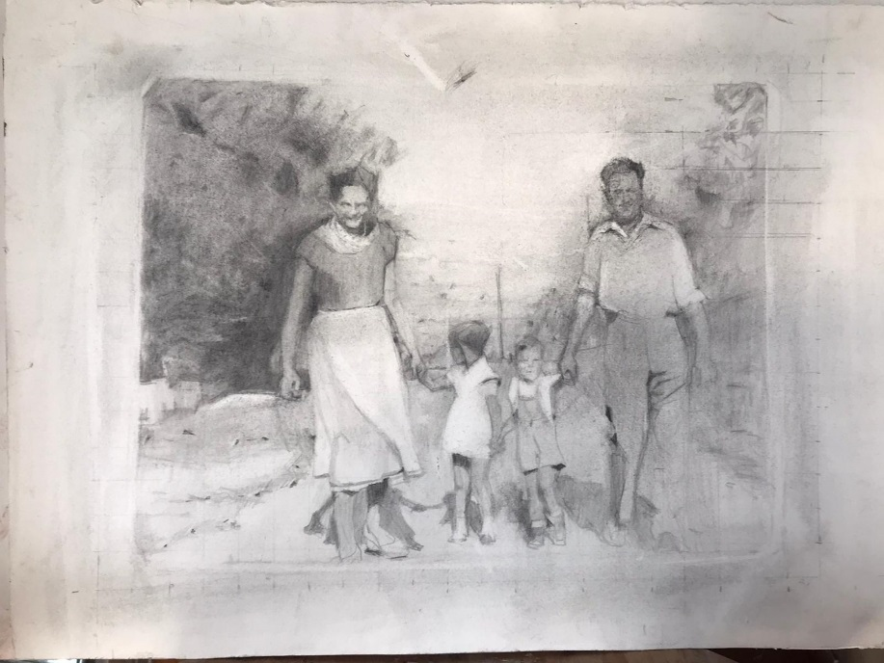
Figure 1: Rachel Nemesh, Yehuda Ha-Nasi st., 2019, graphite on paper, 37/52 cm

- The Big Mother: The Monumental Figure of Katia Nemesh
Three paintings of Nemesh's corpus are dedicated to her mother alone. Her figure occupies nearly the entire space of the large scale paintings. These proportions make Katia look monumental, as seen in Present (Fig. 2). Katia is presented seated frontally, dressed sportively, wearing gray snickers. Her long arms are leaning on the armchair's sides, her fingers neat with red nail polish. Her long legs placed on the floor facing the viewer, which conveys a sense of stability, assertiveness and energy. However, Katia's shut eyes, a repetitive motif in the series, indicate fatigue and old-age, accepted by both the artist and her mother as a kind of reconciliation 'with life, and all she had gone through'.
The way Katia is portrayed embodies two aspects of the artist's perception of her mother, a duality appearing repeatedly in the entire corpus: The earthly aspect, that of a strong, opinionated, independent and ever surviving mother alongside the spiritual aspect seeking to pose the mother at the side of her perished nuclear family, a position existing only spiritually. It seems that the closed eyes, disconnecting her from actual reality may imply a short nap or maybe the imminent death seeking to grant the mother, albeit symbolically that holistic peace to be achieved only by uniting with her perished family. I would like to suggest interpreting Katia’s closed eyes also as an invitation to look into her image being unable to exchange glances with her. The lack of expression caused by the closed eyes allows the viewer a broader reading of the image, beyond a specific eye expression.
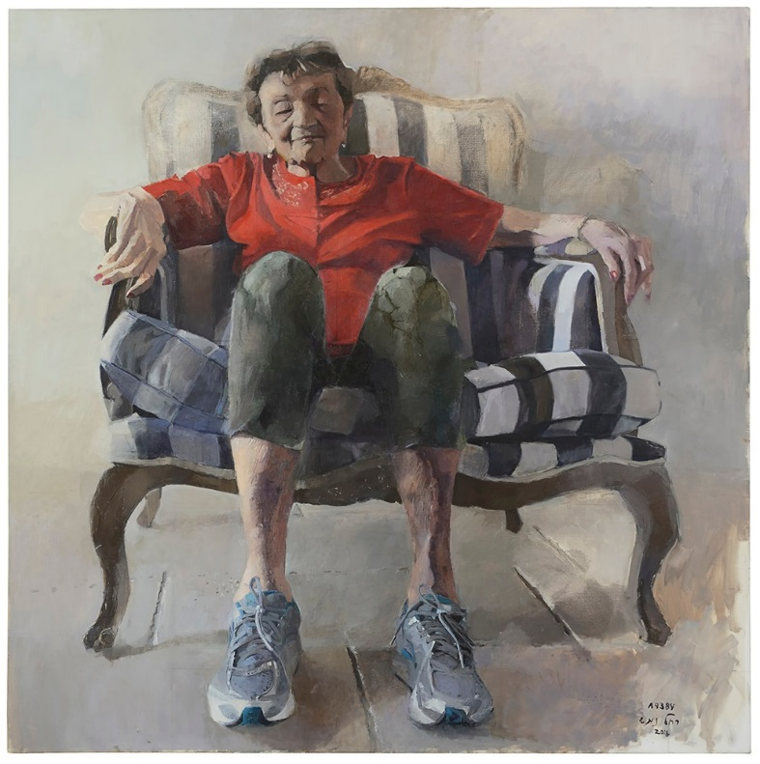
Figure 2: Rachel Nemesh, Present, 2018, oil on canvas, 160/160 cm

Most works portray domestic scenes. In some, an armchair of a sofa represents the home on a small scale, while us, the viewers are watching the figures very closely. I claim that Nemesh's choice of domestic spheres indicates a feminine painting tradition. Griselda Pollock argues that female artists tended to portray domestic spaces and those close to the home as a result of social structuring which enabled them to formulate such spaces independently of Patriarchal perceptions related to male dominance over feminine sexuality. Devoting herself to describing domestic spaces and the feminine body, reflect a feminist practice exercised unconsciously by Nemesh.
In Katia A9384 we again view the mother's figure occupying most of the canvas (Fig. 3). We are looking at her upper body focusing on her face concealed by her left palm and arm. Nemesh's fascinating technique of creating an image through stains and rough strokes is fully manifest here. Using light shinny stains on the right versus dark brown and grey stains on the shady left side render the depicted moment as highly dramatic. At first glance, one would that the strong light causes Katia to cover her face; however, the artist wishes to charge this gesture with much more than sheer direct realism. 'Covering her face also means her covering the whole Holocaust issue…both her and I are hiding behind something. It is also her hiding the feelings from us'.
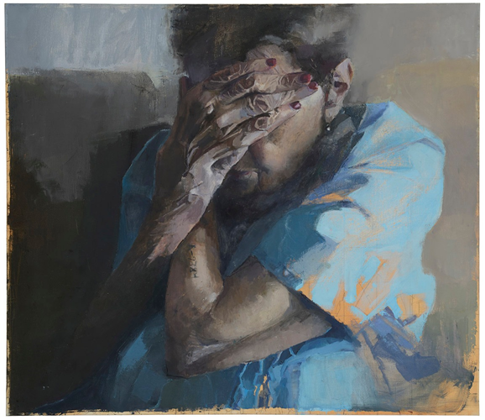
Figure 3: Rachel Nemesh, Katia A9384, 2019, oil on canvas, 70/80 cm

An additional layer of meaning is revealed once we spot the tattooed number on her left forearm, the number tattooed on Auschwitz prisoners' arms while entering the camp. This number has been a leitmotif in Nemesh's works and actually triggered her journey of creating these paintings. She elaborates: 'I decided to paint my mother and the impact of this number on my life and hers, being present all the time'. These words tell us how intense her closeness to her mother is and how strongly she identifies with her. She adds: 'I asked my mother - each time you see this number – do you recall your past? And she said 'yes'. And indeed, it exists both for me and for her and whenever I lay my eyes on the number I feel it inside me'.
For the second generation members, this tattooed number on the parents' arms have always been concrete and constant evidence of 'being there'. Many second generation artists have dealt with this tattooed presence either directly or indirectly. References to the tattooed numbers went far beyond the visual sphere and were common also in the Hebrew poetry of first and second generation poets. It seems that the number as well as the hand and arm, or actually both, very often appear in her work and she does emphasize that 'that hand which touched and did not touch us'. The tattooed number recurs in her works, sometimes also in fictitious positions such as the artist's forearm or the vulture's claw, as seen in Nesherkeh (Fig. 4).
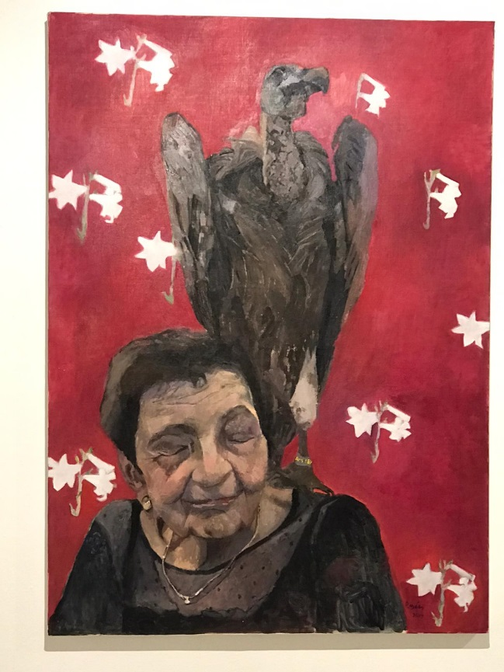
Figure 4: Rachel Nemesh, Nesherkeh, 2019, oil on canvas, 91/126 cm

This painting features a vulture standing on Katia's left shoulder with her depicted in a close-up, her eyes shut again. The vulture figure was based on a stuffed bird, known to both of them exhibited in a natural museum in a village nearby (vulture is Nehser in Hebrew. Nehserkeh is a nickname given to this bird). The fact that this image represents a stuffed bird seeming alive imbues the analogy between it and the mother with a hidden meaning added only one we learn that it is indeed a stuffed bird rather than a living one. The vulture has always been the emblem of strength and superiority, e.g. the Roman empire and the Third Reich, therefore, the artist feels that 'mother very much resembles this vulture'. The analogy between the bird and the mother is emphasized by the tattooed number which was transferred to its claw, looking like a yellow ring. This analogy bears a dual meaning as the Holocaust survivor mother is simulated here with aggressiveness of a raptor. However, since the vulture represents a dead bird, namely it is actually empty and deprived of its strength, it is analogous to Katia who on the outside looks whole and intact while on the inside she is hiding an enormous vacuum.
It is doubtful whether the artist consciously meant it, but her choice of a stuffed bird, to my mind, it far from accidental. This dual meaning indicates her viewing the mother both as a victim of the war and its consequences but also as a force full and sometimes domineering and threatening figure. Her victimization is intensified by the repetitive image of the white lily implying yet another analogy posed by the artist: that of presenting her mother as pure and innocent similarly to Mary mother of Jesus. The lily supports the victimization aspect of that woman who lost many beloved ones in the Holocaust. This double meaning of power dominance survival and presence versus victimization and emotional distress is reflected in each and every painting of Nemesh. This ambivalence is deeply manifested in the largest bulk of paintings of mother and daughter.

- Pieta Versions: Mother-Daughter Relationships
Half of Nemeshe's works making up the corpus exhibited in the show One Flesh, deal with mother-daughter relationships. Their figures appear as very close physically: the mother holding her leaning daughter's head; the mother reclining as to touch her daughter's lain body; the daughter carrying the mother on her back; the daughter leaning against her mother's body and the daughter standing nude next to the mother. This collection of drawings and paintings is based on their encounter in the artist's home: 'mother was visiting me and I asked her to be photographed naked so that we would both be totally exposed. She refused while I got undressed. The whole process took only ten short minutes. It was not really staged but rather things just happened. I asked my husband to take pictures which resulted in about fifteen photos. For the first time I truly felt something different in the way she had touched me. My mother actually gave herself to it. I remember wondering if it would reoccur…it didn't'.
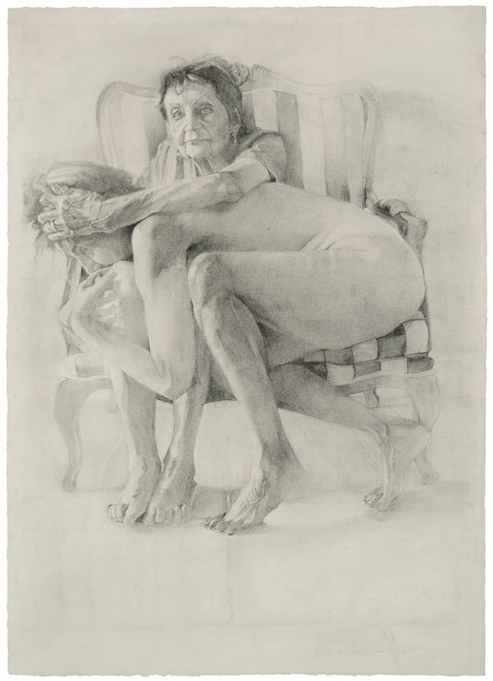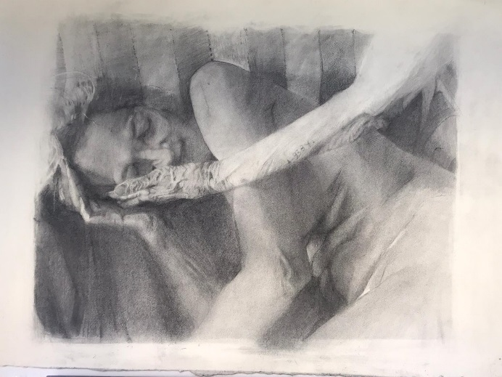
Figure 5: Rachel Nemesh, left: In your palms, 2019, graphite on paper, 67/100 cm. Right: Pieta, 2017, graphite on paper, 75/100 cm.

These acts of an intimate encounter and photographing moments of touch, whose initial practical aim was making the paintings themselves also convey an attempt to make amends or create in illusion of what could have been there between them if it were not for their life circumstances as they happened.
In the drawing Pieta (Fig. 5, right) both mother and daughter squeeze into the striped armchair appearing previously in Present. The naked artist thrusts herself into her mother's lap, who, on her part holds the daughter's head, facing the viewer directly. As the mother body is hardly seen we get the impression of an imaginary body with two heads and four legs. The drawing arouses ambivalent feelings as in spite of the physical proximity, the body language does not convey ease and lacks warmth and tenderness. On the other hand, in the work In your palms (Fig. 5, left) the artist herself is bundled with her eyes shut in the armchair while her mother's hand reaches out tenderly caressing her face. Was it done consciously in all the works to feature Katia on the right hand side of the composition with her left arm with the tattooed number, facing the viewer? Because here too we find this number at the center of the canvas blended into Katia's old and wrinkled skin. Interestingly, the artist chose to describe her own portrait with her eyes shut as if insisting on not seeing, not acknowledging her mother's soft and pleasant gestures toward her. As she herself states that 'lately she has been softer, but it is hard for me…now I can't accept it'.
The artist's compositions reveal a foreground consisting of condensed full intimate scenes painted in a relatively confined space. This approach is typical of modern women artists' space representations towards the end of the 19th and beginning of the 20th centuries. Examples can be found in Mary Cassat and Berte Morisot's works which sought to formulate a feminine intimacy with the viewer alone with a feminine identification with the scenes depicted.
Unintentionally, these works resonate several variations of the Pieta composition of Mother Mary holding her dead son after the ascension. 'When I looked at the photos I couln't believe my eyes. Unintentionally I have alluded to art history's iconography. Facial expressions, the white sheet…I haven't planned to frame a Pieta, but it just happened'. This is the reason why some of the works bear titles taken from Christian iconography and indeed it would not be groundless to understand this whole series as variants of the Pieta.
'In the liveliest place, my mother's bosom, there was death', says Zipi Gon Gross in her book Nobody's Child Anymore (2001). Nemesh, too, repeatedly deals with this bosom space where she, as an infant, was supposed to receive shielding and protecting love and warmth. Instead, according to her, her mother avoided touching her in the first months of her life aiming to immunize her for the hardships of life and also as she was preoccupied mourning her first born child dying at childbirth. The artist's parents had lost their first child, born right after the war prior to their emigrating to Israel. This tragedy allegedly caused due to an anti-Semitic midwife, (according to Katia), has been scorched in the artist's mind as part of her mother's 'over-there' trauma. 'That baby was always there and we would visit his grave occasionally'.
The lacking physical touch is documented in this series as a defiance of all that has been missed but also as proof of a symbiotic mother-daughter relationship despite this lack. As so far described numerous feminist theories emphasize the mother-daughter ties as the most significant of all family ties. Chodorow claimed that feminine identity is shaped throughout intimacy with the mother and maintained that mothers make daughters who are similar to them in their feelings, body and femininity. Therefore, this relationship is characterized by a silent identification and tight emotional involvement which both mother and daughter cling to. Adding to it the second generations members' wish to protect their parents, sparing them pain and sorrow, we are faced with an opposite formula of mother-daughter roles. This role reversing appears implicitly in other works of the series: In The Burden the daughter is carrying her mother on her back (Fig. 6, right); In Mother, I give in (Fig. 6, left) this scene is repeated only here she also being pushed and released by her mother.
Israeli art has recognized a variety of references of the Pieta theme, shedding light on particular aspects of mother-child relationships in various contexts of reality. Ruth Schloss, influenced by German artist Kathe Kollwitz is a prominent example of this phenomenon. In the context of the Holocaust, another second generation artist, Ayana Friedman's works also constitute an interesting perspective of the Pieta. Her Pieta of 1991 focuses on her complex relationship with her Holocaust survivor mother. Instead of a mourning mother Friedman depicts a wooden motherly body to which a wrapped corps-like figure is attached representing a mother protecting her child till death. Rather than protecting her it seems like the mother is actually suffocating her child. Compared to this Pieta, Nemeshe's one is tender and compassionate. It seems that the artist seeks to reveal a loving containing and accepting aspect of her mother, alongside the distressing heavyweight emotions she has generated for her daughter.

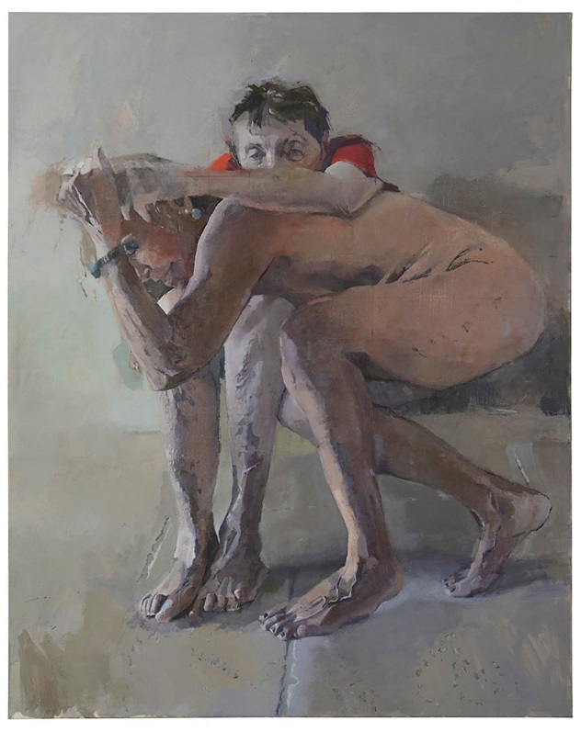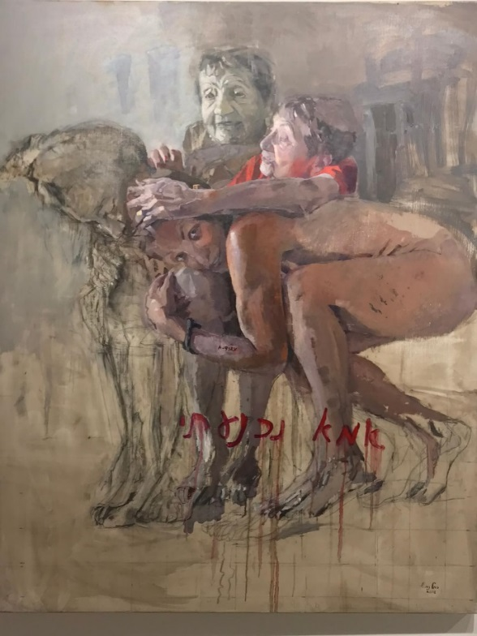
Figure 6: Rachel Nemesh, left: Mother, I Give in, 2018, oil on canvas, 112/140 cm. Right: The Burden, 2018, oil on canvas, 112/140 cm.

Mother, I Give in (Fig. 6, left) is the quintessence of mother-daughter relationship. Here, the two figures are doubled in two different positions: one is that of the mother, dressed in a red blouse seeming to lean against her naked daughter lying in her bosom looking straight at the viewer. On the left hand side, however, we can see a different composition where the mother is sitting upright with her palm pushing away her daughter's head while the latter, her head bending towards the floor is nevertheless trying to upload and carry her mother on her back, similar to the scene in The Burden (Fig. 6, right). Through choosing colorful monochromatic drawing in the left hand side composition versus the more realistic coloration in the right hand side one, the artist creates two distinct scenes in terms of taking place in time. The handwritten red description 'Mother, I give in', intentionally sloppy can be interpreted as the summation of a gradual move starting with the daughter attempting to support her mother and carry her on her back and ending with a silent surrender in the mother's bosom.
What is the nature of this surrender? It, too, can be read in two different ways: giving in to the duty to carry her mother's burden unquestionably and surrending in the face of the mother's metaphorical weight in her life. The mother figure is perceived here like in the others' both as a victim being supported and contained by the daughter and as a pillar for the daughter feeling submissive facing her strong willed mother.
This painting-drawing's style further adds to and sharpens the ambivalent message. This relationship is not one held by the book; rather, it is a dynamic and intricate one. It seems that the artist sought to imbue the body parts with an imaginary movement so as to simulate for the viewer the position shifts and contact changes between them as characterizing their changing bonds. Doubling the figures confuses the viewer's vision concerning the body boundaries, thus making the symbiosis between them a pictorial fact. Rendering this painting sloppily as if unfinished is of course intentional; the cruder and stained the canvas is, the more authentic the scene, thus contributing to exposing the gestures and emotions of the artist at work. The personal exposure becomes profoundly honest through the allegedly crude realistically blunt style.

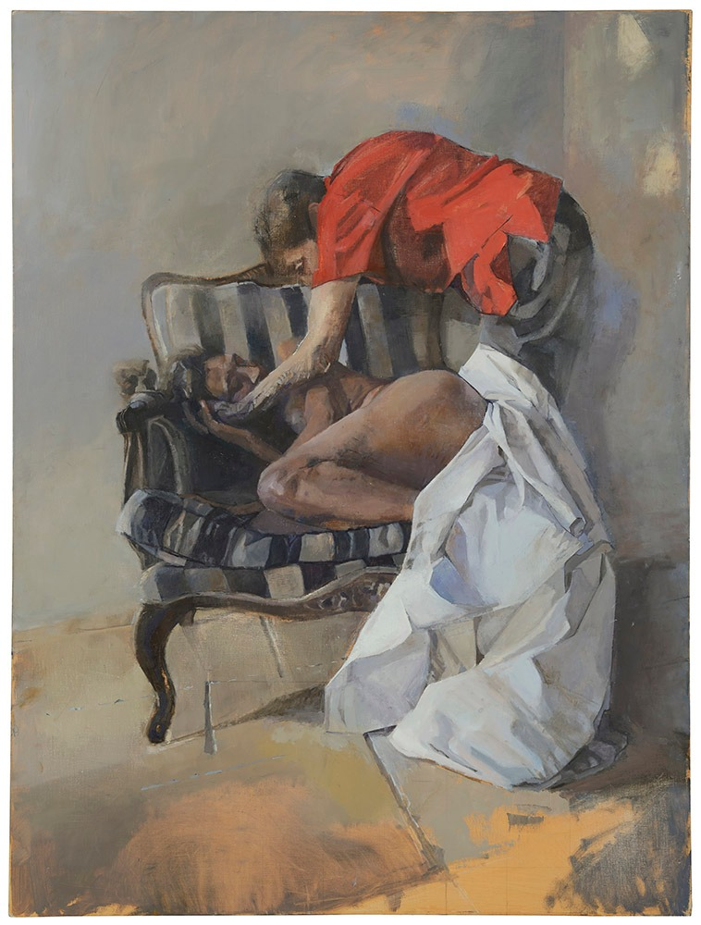
Figure 7: Rachel Nemesh, Getting Out of the Grave, 2017, oil on canvas, 100/133 cm

The Pieta as analogous to Nemeshe's paintings implies to unsolvable victim question: How can it be that the survivor becomes the one turning her daughter as a victim? This analogy is especially salient in the piece where the daughter, the naked artist, is described similar to Christ. Second generation research indicates that indeed they developed a tendency to identify with the parents perceived as living victims. The reversed roles documented in Nemesh's works definitely pose the grown daughter in Christ permanent place who, although lived a flawless life, was doomed to die on the cross to pay for the original sin. Accordingly, Nemesh positions herself, thus generalizing all second generation members as those doomed from the day they are born to live for atoning for humanities sins, performed neither by them nor by their people.
In Getting out of the Grave (Fig. 7) the naked artist is lying in the armchair with a white sheet falling down to the floor and her mother gently bending down to pat her. If the previous paintings are reminiscent of the ascension or the burial of Christ, 'here there are both a burial and also an attempt, on my part, to run away from death by engaging in these materials in my art. Here again the duality – life and death, love and hate, in short – schizophrenia'. Here again the artist is viewed as a victim with her eyes shut while her reclining mother appearing as strong and supportive. A possible reference of Katia's dead baby might be involved here with the artist identifying with it for an instant while Katia's long and tender arm reaching for her stands for love and even a gesture of re-creative healing. The mother is bending towards her daughter with a deforming hump showing under her red blouse.
In this context it is worth noting that the artist has been engaged with yet another theme in all the relevant works – that of old age. Katia Nemesh and Rachel Nemesh, the artist, are both described with effective realism, showing their aging body although old age is not a popular theme in visual culture, including in contemporary art. The hunched body, emaciated joints, age spotted arms and legs, tired eyes – all features are naturally albeit compassionately presented in the paintings. 'It's hard to realize that my old age is going to be exactly like my mom's'. I claim that the artist's insistence on appearing naked in this series reflects an unconscious wish to feel connected to her mother either as her new-born or as a naked woman with the same body as her mother's. As feminist thought suggests, mother-daughter tangled connection continues for life.
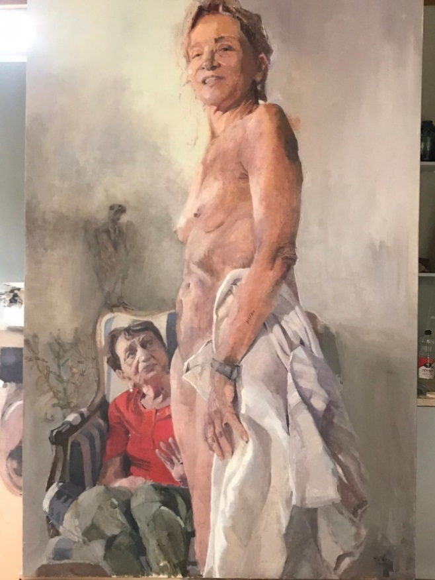
Figure 8: Rachel Nemesh, Wishing to Fly, 2019, oil on canvas, 114/171 cm

In Wishing to fly (Fig. 8), the artist is standing naked, with the same white sheet from previous paintings covering part of her body. Her mother is seated in the striped armchair behind with the two attributes – the brown vulture and lily - faded into the stained background. Both motifs appear in other paintings in relation to the figure of Katia. Katia's expression and gesture convey some discontentment at her naked daughter. The artist who was described reclining into the armchair in previous paintings, is now fully upright, facing the viewer with a defying smile on her face. While the reclining figure resembled the ascension, this one echoes the resurrection. After painting herself in this position, the artist noticed she looked similar to Mordechai Anilevitch's sculpture in Yad Mordechai. Another reference, this time from Holocaust art of survivors, is that of naked women being humiliated and trampled by Nazi soldiers, for example the art of Naomi Yudkovski and that of Ella Liberman-Shiber. Was it hard for Katia to watch her daughter naked because of these kinds of references? Did it bring memories of the harsh past she had experienced? These questions are unanswerable.
Analyzing this painting regarding its compositional division, it seems that the lower part is where the painting's weight is mostly felt whereas the upper part feels much airier and emptier. This upper part is covered with light stains blocking any view possible, rendering the figurative scene dominant. The artist's head touches the upper frame, hindering her wish to fly away (as the title suggests). 'Though I'm tall and upright, I can't really fly away'. In addition to this unfulfilled desire to escape, the tattooed number of Katia appears here on the artist's arm. Her identification with her mother is complete, when she becomes one with her, at least in one painting.
This work embodies a tension between the daughter's wish to fly away and her destined place close to her mother. The duality of mother-daughter relationship, where the daughter's wish for autonomy and independence might be interpreted by her mother as betrayal, makes her feel trapped in this position, as Leyla Navaro explained. The Pieta versions reflect Presiado's models of motherhood, shaped by the artist daughters as complex and traumatic. These models demonstrate the Holocaust's profound influence on the strongest bond of all: mother-daughter's relationships.

C. Body Parts
Nemeshe's corpus contains two paintings focusing on body parts depicted as cut off from the body. Sealed in Skin (Fig. 9) features full arms and forearms as an assembly of body parts, non-attributable. However, one anchor constituting the core of this work is definitely there: Katia's tattooed number standing out dark against her lit skin. A flesh of light seen falling on her arm, painted with white strokes highlights the letter A and the numerals even more as if written on a billboard. Unlike previous paintings where it appeared as part of the figure here it is cut off from it thus enabling both the artist and the viewer a chance to explore the number itself as a significantly charged sign and symbol. Paradoxically, the metonymical number is here detached from the person it belongs to. It has become anonymous as opposed to its original function. This special composition, leaving the figure out and the body parts fragmented, might imply mass graves or other stereotypical sights of Holocaust mass murders. In this case, this number becomes a general signifier standing for the horrid anonymity of the Holocaust atrocities. An additional meaning implied in this work might suggest the number's destiny after the person carrying it dies. This issue has engaged various writers and poets and Katia Nemesh herself who asked for the number to be removed after her death.
Another work dedicated to detached body parts is Footprints (Fig. 10). This is a surrealistic painting depicting Katia's, Rachel's and her daughter's feet, namely three generations feet entangled and overlapping. This is the only work where the granddaughter is represented, which stresses the effect of the Holocaust on the third generation as well. Each pair of feet appears a few times, some of which tramp on the floor while other seem to hover in space. The lack of time, body and space again arouses a connotation of piled up dead bodies.

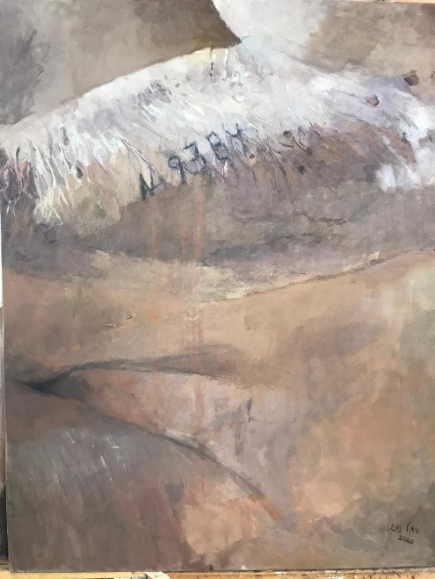
Figure 9: Rachel Nemesh, Sealed in Skin, 2020, oil on canvas, 79/99 cm.

Figure 10: Rachel Nemesh, Footprints, 2019, oil on canvas, 75/175 cm

D. Katia in her domestic space
This category consists of three paintings where Katia is described sitting in the kitchen and in her living room and getting up from bed in her bedroom. As opposed to the empty blocked spaces of the Pieta series here the artist has paid her artistic attention to shaping whole room compositions full of furniture and objects simulating a thick blanket shielding the person cuddle up in it. The neatly organized furniture, the books on the shelf attesting to Katia's love of languages and her past career as an English teacher, the Hungarian broidery runners and family photos – all these attributes tell Katia's story highlighting her cultural heritage. Unlike the minimal and austere nature typical of most of her other works, here we are observing a colorful and richly textural canvases. It is a celebration of still life compositions, a genre often used by Nemesh.
Describing her mother sitting alone in her living room (Fig. 11, right) or leaning against the kitchen table (Fig. 11, left) the artist explores the issue of rehabilitation and going back to normal. This poignant question, implying the cliché of triumphing over life is being asked by every item in these interiors. Does the fully decorative, bourgeois living room really make up for her painful past? Can material objects compensate Katia for her loneliness conjuring distant cruel memories?
The artist admits that her mother could never really be consoled with her new life after the Holocaust because her loved ones who were murdered were always in her heart. The domestic space described in the three paintings functions as an illusion for compensation. It hides the tragedy of an unsolved situation of living a life with a huge absence. Katia's shut eyes could indicate her distinct presence, having an inner world reaching out for her memories, disconnected to her protected surroundings – her own domestic space.

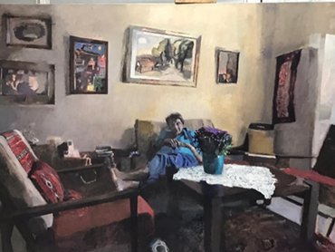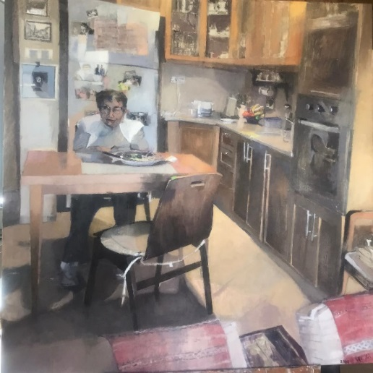
Figure 11: Rachel Nemesh, Left: In the Kitchen, 2020, oil on canvas, 108/108 cm. Right: In the Living Room, 2020, oil on canvas, 96/136 cm.

Conclusion
This article has presented and analyzed Nemeshe’s work assemblage dealing in her mother, a Holocaust survivor, and their relationship. Two major themes were employed as a discussion framework: Israeli art focusing on the Holocaust performed since then and feminist theories dealing in mother-daughter relationship. Interviews with the artist and a short documentary made for the One Flesh exhibition (March-Aug, 2020) also extensively contributed to the understanding of the works.
The corpus comprises about twenty paintings and drawings analyzed thematically and categorized into four groups: a. Big Mother – three paintings depicting Katia’s monumental figure. B. Pieta Versions – ten works featuring mother-daughter relationships. C. Body Parts – two paintings describing cut off, distinct body parts. D. The Domestic Space comprising three paintings of Katia’s home. These four themes are well integrated into Second-Generation art, thus embodying certain motherhood models, suggested by Presiado.
This article claims that the whole assemblage expresses an ambivalence related to mother-daughter connections which poses various contrasts mutually intertwined, yet creating ambiguity seen in every work. Alongside a strongly present mother, threatening at times, the 'Big Mother', this figure is viewed by the daughter also as victimized and lonely. The threatened, submissive daughter, carrying her mother’s painful life burden on her back, frequently defending her, is also presented here as defiant and one who seeks to break free and fly away. The mother-daughter ties are described through various versions of the Pieta iconography, borrowed from Christian art. The mother is holding her lifeless daughter in her bosom, a symbol of the Second-Generation being themselves victims. As a Holocaust survivor, having lost her whole family, Katia bears her tattooed Auschwitz number as an eternal reminder of the trauma. This left arm tattoo is constantly repeated in Nemeshe’s work not necessarily on the mother’s arm but also on the artist’s own body and on the vulture’s claw. Paradoxically, the vulture appearing as Katia’s attribute, culturally representing power and superiority, is here proven as hollow, being only a stuffed bird’s image. Like the mother, its outer appearance does not essentially indicate its inner being.
The mother and daughter are depicted in the semi-staged series both as being close to one another and alienated. In line with Presiado's motherhood models, Nemesh created complex mother-daughter images, reflecting the trauma of the Holocaust as it has been delivered from the mother to her daughter. The duality in their relationship is significantly reflected in Mother, I Give in where on the one hand, the daughter is carrying her mother on her back while the mother on her part is pushing the daughter away from her. For both, their mutual symbiosis seems unsolved. Here we witness two distinct bodies made into one thus exemplifying feminist theory related to mother-daughter relationships.
Nemeshe’s uniqueness is conveyed by her realistic style focusing meticulously on details of body, face, skin and garment, thus formulating a strict feminine language. As Helene Cixous states, women must write in white ink, namely based on their feminine experiences as mothers and daughters. Nemesh not only presents the themes of mother-daughter relationship but also expresses them mostly through using images of the material body. The body of both mother and daughter is closely described, showing natural aging signs – spots and wrinkles – as realistically as can be. No beautification was done here; on the contrary – it is an authentic expression of aging femininity. This feature is rarely seen in contemporary Israeli art, thus constituting a significant feminist contribution.
The two paintings of Nemesh describing body parts are nearly surrealistic. Ironically, the identification-tattooed number appears among other painted limbs anonymously as not belonging to any specific person. Similar to this concept, the three pairs of feet are depicted detached from the figures they belong to. The chaotic depiction inevitably evokes the image of mass graves. Personal organs become general, and pictorial poses become stereotypic.
Unlike the non-place background of the Big-Mother images, the Body Parts paintings and the Pieta versions, not embedded in any particular space, in the domestic space group, the modest home of Katia is fully described. The universal touch of the Pieta scenes, shaping a mother-daughter iconography, has changed in Katia's domestic home into a very private portrayal. It is not surprising, thus, to observe Katia in her kitchen, living room and bedroom surrounded by her private attributes such as furniture, appliances, family photos, books, embroidered items, etc. There is no symbolism here, but a close look into the life of an elderly Holocaust survivor, whose bourgeois home would not compensate for her traumatic life. Katia's cultural heritage, evident in all the objects surrounding her still leaves her a lonely figure trying to live a normal life, forever carrying the trauma. Katia is presented with her eyes shut so as to stress the gap between the illusion of a safe and cozy home and her severe inner pain.
Rachel Nemeshe's assemblage discussed in this article constitutes an original contribution to Israeli art dealing in the Holocaust from a perspective of a Second-Generation daughter. The feminist reading emphasized the uniqueness of the mother-daughter relationship in the light of the Holocaust – a perspective rarely discussed. This bond is expressed in a sharp realism, reflecting a feminine artistic language focusing on the ageing body. Nemeshe's personal journey to investigate her relationship with her mother has become a cultural story touching not only on two generations of Holocaust survivors and their daughters, but also on mothers and daughters in general.

Notes Gon Gross, Nobody's Child Anymore.
Brutin, The Inheritance, 9, 14.
Wardi, "A Certain Kind of Identity".
Wardi, Memorial Candles.
Brutin, The Inheritance, 18.
Berberich,"Introduction", 3-4.
Rivka Miriam exhibited creations that dealt in the Holocaust in the 1960s in a range of galleries, yet they were not well received by the public or the artistic institution at that time. To read about the historiography of the Holocaust in Israel see: Steir-Livny, Let the Memorial Hill Remember, 17-36.
Brutin, The Inheritance, 19.
Ibid, 22.
Rosen, "Seen and Unseen Trauma".
In 1979 and in 1980, Moshe Gershuni displayed two exhibitions that dealt in the Jewish Identity and the Holocaust at the Tel Aviv Museum and in Biennale, Venezuela. See: Brutin, The Inheritance, 19.
Brutin, The Inheritance, 19.
Ibid, 23.
Gendron, "It's the Real Thing", 415; Brutin, The Inheritance, 23.
Gilerman, "Holocaust Representation in Art".
Maor, "The Sabra".
Shapira, "The Suppressed Syndrome".
Manor, "From Rejection to Recognition".
Aharonson, "Memory as History".
Berberich, "Introduction", 5.
Ibid.
Gatenio, Lying Within the Skin, 20.
Brutin, The Inheritance, 25.
These solo exhibitions included: Haim Maor’s Marked 1975-2002 that dealt in marking people as victims of assault. See Brutin, The Inheritance, 26; Anat Massad’s Please Attend Dressed in White Shirts in 2003, that dealt in the Zionist ethos and the Holocaust, and Ayana Friedman’s Chic Paris in 2004 that dealt in identifying with the Holocaust survivors and legacy from a social-cultural aspect.
Brutin, The Inheritance, 26.
In 1989 an artist, Honi HaMe'agel, presented an exhibition called 'The scapegoats' in which he identified with the tortured and humiliated Jewish victims and with the Nazi cruelty. In 1997, Ram Katzir presented 'Within the Line' at the Israel Museum – an exhibition that dealt in Nazi propaganda and created significant yet heated public discourse. See: Litman, "Parliament Member, Anat Maor". Katzir claimed that the exhibition is designed as a memorial space with no intention to offend. See: Katzir, "Who is refused to look?", 43.
Steir-Livny, Let the Memorial Hill Remember, 79-112.
Sperber, "How has dealing in the Holocaust become provocative?"
To read about the reactions to the exhibitions, see: Lori, "It was an explosion".
Boaz Arad’S VoozVooz, exhibited at the Contemporary Art Gallery in Tel Aviv in 2007, stirred up a public storm as the artist directly and bluntly addressed the image of Hitler, leading to harsh questions about dictatorship, evil, violence, and oppression in general. This exhibition was an example of the provocative Holocaust discourse that has been common in Israeli art since the mid-1990s. See: Sperber, "How has dealing in the Holocaust become provocative?"
For example, Dina Shenhav's exhibition at the Hellena Rubinstein's gallery that included images of Nazi officers made of beads, Yoav Ben-David's exhibition of paintings that included Alice in Wonderland with two SS soldiers, and Dov Or-Ner who sketched sexual scenes of Hitler. See: Sperber, "How has dealing in the Holocaust become provocative?"
Ibid.
To read about the typology of Holocaust art in Israel see: Katz-Freiman, "Don't Touch My Holocaust" and Brutin, The Inheritance, 30-31.
To read about the discourse on Yocheved Weinfeld’s exhibition, see Brutin, The Inheritance, 196-203 as well as discussions on the artwork of Shosh Kormosh, Talia Tokatli and Dorit Reingart in Gatenio, Lying Within the Skin.
Presiado, Motherhood in the Shadow of the Holocaust.
Shaplan-Katzav, "Mother's Voice", 258-259.
Ibid, 261.
Guilat, "Motherhood and Nationalism".
Amishai-Maisels, Depiction and Interpretation.
Baumel-Schwartz, Kibbutz Buchenwald: Survivors and Pioneers.
Potter, "Feminist Interpretations"; Hertzog, "Subjugated Motherhood".
Persiado,"The Expansion and Destruction".
Hertzog, "Subjugated Motherhood", 2.
Persiado, "The Expansion and Destruction", 199.
Friedman, "Motherhood in light of Theory", 203.
Interview with artist, 2020
Dekel, Gendered, 145.
De Beauvoir, The Second Sex.
Dinnerstein, The Mermaid and the Minotaur.
Chodorow, The Reproduction of Mothering.
Rich, Of Woman Born.
Ruddick Maternal Thinking.
Dekel, Gendered, 147.
Chodorow, The Reproduction of Mothering.
Gilligan, In A Different Voice.
Dekel, Gendered, 148.
Flax, The Conflict between Nurturance and Autonomy".
Friedman, "Motherhood in light of Theory", 204.
Navaro, "Snow Whites".
Friedman, "Motherhood in light of Theory", 205.
Ruddick, Maternal Thinking.
Rich, Of Woman Born.
Dekel, Gendered, 150.
Cixous,"The Laugh of the Medusa".
Ibid.
Kristeva, Desire in Language, 242
Dekel, Gendered, 151.
Irigary, "And the One Doesn't Stir".
Interview with the artist, 2020.
Interview with the artist, 2020.
Interview with the artist, 2020.
Presiado, Motherhood in the Shadow of the Holocaust, 30
Interview with the artist, 2020.
Shachnai Yaacobi, One Flesh.
After completing the painting, the artists realized a resemblance between her mother's posture and that of Abraham Lincoln's sculpture by D. C. French, 1920.
Interview with the artist, 2020.
To read about the gaze's significance in Holocaust drawings, see: Leclerc, "Re-Presenting Trauma".
Pollock, Vision and Difference, 78-79.
Interview with the artist, 2020.
Documentary of Nemesh, 2020.
Ibid.
Brutin, The Inheritance, 85-86.
Interview with the artist, 2020.
Ibid.
Documentary of Nemesh, 2020.
Interview with the artist, 2020.
Pollock, Vision and Difference, 86-87.
Interview with the artist, 2020.
Ibid.
Dekel, "In Kathe Kollwitz Shoes?".
Presiado, Motherhood in the Shadow of the Holocaust, 19-20.
Brutin, The Inheritance, 177.
Interview with the artist, 2020.
Ibid.
For reading on women's sexual abuse as reflected in Holocaust art, see: Presiado, "Multi-Generational Memory".
Interview with the artist, 2020.
Navaro, "Snow Whites".
Documentary of Nemesh, 2020. References Amishai-Maisels, Ziva. Depiction and Interpretation: The Influence of the Holocaust on the Visual Art, Oxford: Pergamon, 1993. Baumel-Schwartz, Judy. Kibbutz Buchenwald: Survivors and Pioneers. Rutgers University Press, 1997. Berberich, Christine. "Introduction: The Holocaust in contemporary culture". Holocaust Studies, 25:1-2, 1-11, 2019. DOI: 10.1080/17504902.2018.1472871 Brutin, Batya. The Inheritance: The Holocaust in the Artworks of Second Generation Israeli Artists. Jerusalem: Magnes, 2015. [Hebrew] Cixous, Helene. "The Laugh of the Medusa" Signs, Vol. 1, No. 4, 875-893 (1975) 1976. Published by: The University of Chicago Press Stable URL: http://www.jstor.org/stable/3173239. https://www.mun.ca/philosophy/Cixous_The_Laugh_of_the_Medusa.pdf Chodorow, Nancy. The Reproduction of Mothering: Psychoanalysis and the Sociology of Gender, Berkeley: University of California Press, (1978) 1990. De Bovoir, Simon. The Second Sex, New York: Random House, (1949) 1974. Dekel, Tal. "In Kathe Kollwitz Shoes? Gender Aspects in Ruth Schloss' Art, Bezalel: Journal of Visual and Material Culture, 2009. http://journal.bezalel.ac.il/he/protocol/article/3050 [Hebrew] Dekel, Tal. Gendered: Art and Feminist Theory, Tel-Aviv: Hakibbutz Hameuchad, 2011. [Hebrew] Dinnerstein, Dorothy. The Mermaid and the Minotaur: Sexual Arrangements and Human Malaise, New-York: Harper Colophon, 1976. Flax, Jane. "The Conflict between Nurturance and Autonomy in Mother-Daughter Relationships and within Feminism", Feminist Studies, Vol. 4, No. 2, Toward a Feminist Theory of Motherhood, 171-189 (Jun., 1978). DOI: 10.2307/3177468 https://www.jstor.org/stable/3177468 Friedman, Ariella. "Motherhood in light of Theory", Venues of Feminist Thinking: An Introduction to Gender Studies, edited by Niza Yanay, Tammar El-Or, Orly Lubin and Hannah Naveh, 189-242, Tel-Aviv: The Open University of Israel, 2007. [Hebrew] Gatenio Anat. Lying Within the Skin: Images of Silence and Absence in the Art of Second Generation Holocaust Survivors. Kiryat Tivon: The Memorial Center Art Gallery, 2002. [Hebrew] Gendron, Sarah. "It's the Real Thing: The Limits of Realism in Holocaust Visual Art", Contemporary French and Francophone Studies, 13:4, 415-422, 2009. DOI: 10.1080/17409290903096277 Guilat Yael, "Motherhood and Nationalism: The Voice of Women Artists in the Discourse on Bereavement and Remembrance", Israel 18-19, 237-267, 2011. [Hebrew] Gillerman, Dana. "Holocaust Representation in Art has transformed radically over the last decades: Live and Dye as Eva Braun as a Case Study". https://basis.org.il/%D7%9E%D7%92%D7%96%D7%99%D7%9F/%D7%97%D7%93%D7%A9%D7%95%D7%AA/%D7%93%D7%91%D7%A8-%D7%94%D7%A2%D7%95%D7%A8%D7%9B%D7%AA--%D7%93%D7%A0%D7%94-%D7%92%D7%99%D7%9C%D7%A8%D7%9E%D7%9F-16.2 16.2.2016 [ Hebrew] Gilligan, Carol. In a Different Voice: Psychological Theory and Women's Development, Harvard University Press, 1982. Gon Gross Zipi, Nobody's Child Anymore, Tel-Aviv: Zmora-Bitan, 2001. [Hebrew] Hertzog, Esther. "Subjugated Motherhood and the Holocaust", Dapim: Studies on the Holocaust, 30 (1), 2016, DOI: 10.1080/23256249.2016.1126983 Irigaray, Luce. "And the One Doesn't Stir Without the Other", Signs: Journal of Women in Culture and Society 7, no. 1, 60-67. (Autumn, 1981). https://doi.org/10.1086/493859, 1980 Katz-Freiman, Tami. "Don't Touch My Holocaust – Analyzing the Barometer of Responses: Israeli Artists Challenge the Holocaust Taboo", in Impossible Images: Contemporary Art after the Holocaust, edited by Shelley Hornstein, Laura Levitt and Laurence J Silbersyein, New York: New York University Press, 129-154, 2003. Katzir, Ram, "Who is refused to look?", Kol Ha'er, Jan. 24, 43, 1997. [Hebrew]. Kristeva, Julia. Desire in Language: A Semiotic Approach to Literature and Art, New York: Columbia University Press, 1980. Leclerc, Josée. "Re-Presenting Trauma: The Witness Function in the Art of the Holocaust", Art Therapy, 2011, 28:2, 82-89, DOI: 10.1080/07421656.2011.580181 Litman, Shanni,"Parliament Member, Anat Maor, Asking Minister of Education to Cancel Exhibition 'Within the Line'", Ha'aretz, 21.1.1997, D3. [Hebrew] Lori, Aviva, "It was an explosion", Haaretz, Sep. 12, 2003. [Hebrew] Maor, Haim. "The Sabra Who have not Walked in the Fields, on Second-Generation Art", in Yoel Rapel (ed.), Hidden Memory, Revealed Memory: Holocaust Consciousness in Israel, Tel-Aviv: Misrad Habitachon and Masuah, 137-153, 1998. [Hebrew]. Manor, Dalia. "From Rejection to Recognition: Israeli Art and the Holocaust", Israel Affairs, 4, 253-277, 1998. Navaro, Leyla. "Snow Whites, Stemothers and Hunteres: Gender differences in competition", Unpublished paper, presented at IAGP conference, London, 1998. Potter, Erika. "Feminist Interpretations of Holocaust History", Mount Royal Undergraduate Humanities Review, 4, 34-44, 2017. Presiado, Mor. Motherhood in the Shadow of the Holocaust, Catalogue, Bar-Ilan University, 2014. [Hebrew]. Presiado, Mor. "The Expansion and Destruction of the Symbol of the Victimized and Self-Sacrificing Mother in Women's Holocaust Art", Nashim: A Journal of Jewish Women's Studies & Gender Issues, 33, 177-208, 2018. Presiado, Mor. 'Multi-Generational Memory of Sexual Violence during the Holocaust in Women's Art', in War and Sexual Violence New Perspectives in a New Era, edited by Sarah K. Danielsson, chapter 8., 2019. Pollock, Griselda. Vision and Difference. Feminism, Femininity and Histories of Art, London and New-York: Taylor & Francis, 2013. Rich, Adrienne. Of Woman Born: Motherhood as Experience and Institution, Norton, 1986. Rosen Roee. "Seen and Unseen Trauma, On Traces of the Holocaust in Moshe Gershuni's Art and Its Place in Israeli Art". Studio 76, Oct. 1996, 44-59. [Hebrew]. Ruddick, Sara. Maternal Thinking: Towards a Politics of Peace, Boston: Beacon Press. Shachnai Yaacobi Michal. "One Flesh/Rachel Nemesh", One Flesh, Kiryat Tivon: The Memorial Center Art Gallery, 2020. [Hebrew]. Shaplan-Katzav, Hadara. " Mother's Voice: Israeli Women Artists and the Monther's Representations". In Will You Listen to My Voice? Representations of Women in Israeli Culture, edited by Yael Azmon, 258 – 273. Van Leer Jerusalem Institute and Hakibbutz Hameuchad, 2001. [Hebrew]. Shapira, Sarit, "The Suppressed Syndrome: Holocaust Imagery as a Taboo in Israeli Art", The Israel Museum Journal 16, 35-46, 1998. Sperber, David. "How has dealing in the Holocaust become provocative?". Ma'arav: Art, Culture, Media. 2009. http://maarav.org.il/archive/?p=1314. [Hebrew]. Steir-Livny, Liat. Let the Memorial Hill Remember: Holocaust Representation in Israeli Popular Culture. Tel-Aviv: Resling, 2014. [Hebrew].

